Report on Improving the Environmental Performance of a Monitor


COVER PAGE
3. Introduction
-Brief description of the reports Objective and results
- Baseline Assessment
-Goal and scope
4. Definition for the Life Cycle Assessment
- Functional Unit
-Data quality
-.assumptions
.limitations
5 Inventory analysis (materials and CED calculations)
- Impact assessment and interpretation
- LCA of general monitor

- Business Model Innovation
7 Sustainable Business Model addressing the hotspots previously identified
- Product Design Innovation
-Materials
-Providers
9 manufacturing location & transport –
Parts replacement or elimination
- Life Cycle Assessment (improved product)
Inventory analysis (materials and CED calculations)
Comparison and interpretation of impact assessment
Impact on Resources, Energy & Waste
13 conclusion
. Introduction
Electronic products like computer monitors can have a large environmental impact throughout their entire life cycle. This includes the materials extracted from the environment to make them, the energy used during manufacturing, the electricity they consume when in use, and the waste created when they are thrown away. These impacts contribute to problems such as resource reduction, carbon emissions, and the growing issue of e-waste around the world. Because of this, it is important to understand how a product affects the environment at each stage of its life .Life Cycle Assessment (LCA) helps us do this by analysing the environmental footprint of a product and identifying where improvements can be made in design, materials, and business models.
The aim of this report is to examine the life cycle of a general monitor, identify the main environmental hotspots, and redesign a more sustainable monitor. Our redesigned monitor is a 24-inch OLED office monitor, created using LCA results to reduce energy use, improve recyclability, and support circular economy strategies. The results show that the use phase and production stage are the biggest contributors to environmental impact.
By switching to OLED technology, using recycled materials, and introducing circular business practices such as leasing and refurbishment, our new monitor significantly reduces total energy demand and overall environmental impact.
Baseline Assessment
Goal and scope
The goal of the baseline assessment is to evaluate the environmental impact of general monitor across its entire lifecycle, from raw material extraction to end-of-life treatment. The LCA covers five key stages: raw materials, manufacturing, and distribution, use phase and end of life.
In our project, we examined a general monitor as a baseline and compared it with our redesigned 24-inch OLED office monitor where we made several improvements. We researched how much raw material is used in general monitor where they are manufactured, how much energy it uses during its lifetime, and what happens to it when it is thrown away. Below we showed percentage impact for each stage.
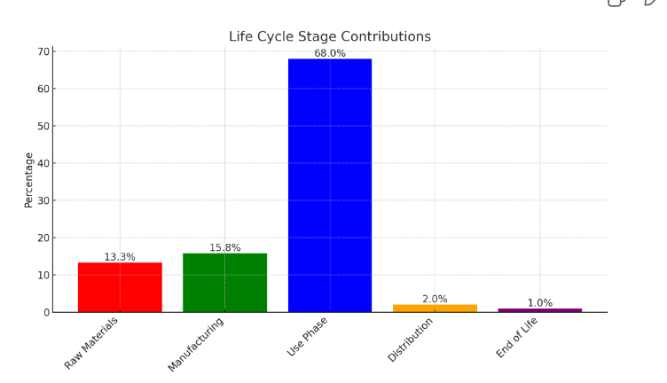
.
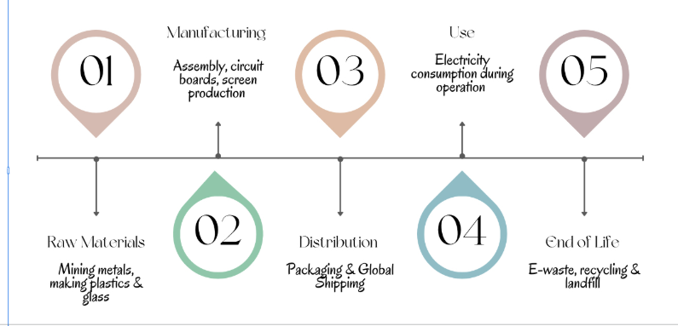
What is the Life-Cycle Assessment?
LCA is a systematic approach for assessing the environmental aspects and potential impacts associated with a product, process, or service. It considers all life stages including raw material extraction, production, distribution, use phase, and end of life to support more sustainable design and decision making,
The functional unit:
For this LCA we focus on 24-inch office monitor used over five years. This is our functional unit and it sets the standard for what we’re analyzing. It ensures we have a fair and consistent way to compare the environmental impacts of different monitors.
Even though monitors vary in size and technology, we stick to this single functional unit so the comparison is balanced. This way when we compare a general monitor with our redesigned 24-inch OLED office monitor, we measure materials, energy use, production, and end-of-life treatment on the same basis this helps keep the results reliable and meaningful.
Data Quality:
We took Most of the basic information such as materials, energy use, and common monitor from public environmental reports on general computer monitors, academic LCA references, and typical component data sheets. These sources are generally reliable but some details such as exact material composition or the production energy use can be different depending on the business and model.
Assumptions:
- Both the baseline and redesigned monitors are assumed to have a 5-year lifespan, which is typical for office use.
- Energy consumption was estimated using average yearly values for common monitor types (CCFL, LED, OLED).
- Transport distances were estimated based on standard global supply chain routes.
- We assumed that a typical user operates the monitor 8 hours per day, 5 days a week.
- Recycling efficiency at end-of-life was based on average WEEE recycling rates.
Limitations:
Our research had a few limitations we could not find the exact manufacturing emission data for specific monitor brands, so we used industry averages instead. We also know that electricity use can change depending on how people actually use their monitors, so our estimates may not match real-world patterns. Additionally processes like rare metal mining involve complicated global supply chains that are not always transparent. Lastly, our LCA mainly focuses on energy demand (CED) and materials, and doesn’t cover all impact category, such as water use or toxicity.

Impact Assessment & Interpretation
This stage examines the environmental impacts linked to materials, energy use, manufacturing, and end-of-life treatment using the results from inventory analysis. In our LCA, we focused on three main impact categories global warming potential, cumulative energy demand (CED), and e-waste generation. These indicators show where most of the environmental impact occurs across the monitor’s five-year lifespan.
The analysis shows that the use stage contributes the most overall, mainly because of the electricity required to run the monitor. Manufacturing also has a significant impact especially due to the materials used in the display, circuit boards, and casing. Transport and disposal contribute less but still matter because of e-waste and limited recycling.
When we compare the baseline monitor with our redesigned 24-inch OLED, we see both benefits and trade-offs. Our redesigned 24-inch OLED office monitor uses less energy during operation which reduces its global warming potential over five years. However, producing the OLED panel can require more energy or specialised materials which increases impacts during manufacturing. Even so the lower energy use during operation means the overall life cycle impact is reduced.
Overall, the results suggest that improving energy efficiency during the design stage brings the biggest environmental benefits. Reducing electricity use during the monitor’s lifetime is one of the most effective ways to reduce its footprint.
LCA of General monitor:
RAW material:
The materials that were used in general monitor were Aluminium, glass, plastic, steel, and electronic parts for its monitors. These materials have to be mined, refined, and processed before you can use them
Manufacturing:
Current monitor suppliers make the materials into parts like the screen, aluminium case, circuit board, and power supply. They shape and prepare each piece.
Use phase:
The use phase starts when customers use the monitor General monitors consume electricity over their lifetime, and most of the company designs them to be energy-efficient to reduce environmental impact also we analysed from couple of environmental reports most of their Use phase is significantly high.

Distribution:
Most company ships finished monitors from factories to warehouses, stores, and customers worldwide via ship, air, and road, adding to its carbon footprint.
End of life:
At the end of their life, General monitors can be recycled or traded in, allowing companies to recover aluminium, glass, and electronics to reduce waste and reuse materials.
In most of the reports it stated that their monitor produces a total of 1040 kg CO2e over its lifecycle with the greatest impacts arising from production and use phase
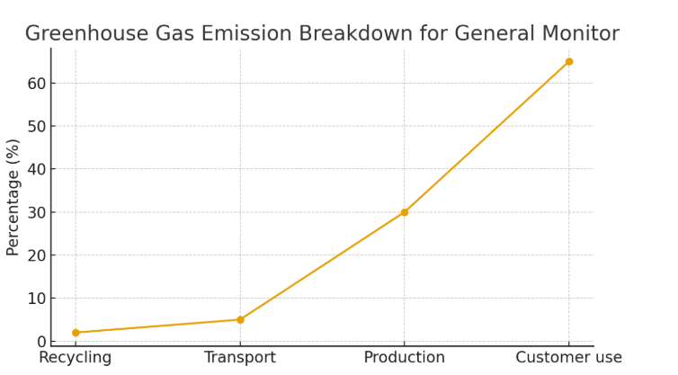
The line graph above shows the environmental impact per lifecycle stage for general monitor’s customer use and production are highest. Also in the some of the reports it stated That Greenhouse gas emissions have an impact on the planet’s balance of land, ocean, and air temperatures.
Business Model:
The circular business model for our 24-inch OLED office monitor was designed directly from the hotspot results of the baseline LCA. The three major hotspots identified were:
- High energy consumption during the use phase
- Material impacts from aluminium, plastics, and electronic components
- Increasing e-waste due to poor end-of-life recovery
Our new business model tackles each hotspot through circular economy strategies that extend product life, reduce resource use, and improve material recovery.
Customer Value proposition: The new 24 inch OLED office monitor offers customer a monitor that Delivers high durability making repairs quick and affordable, Lower energy costs due to OLED efficiency directly reducing the largest hotspot the use phase and it also guaranteed take back and refurbishment service ensuring responsible end-of-life management. This improves the environmental impact while giving the customers better long term values.
Customer relationships: we wanted to focus on long Term support through a repair for a service and sustainability engagement with features like extended warranties encouraging customers to keep the product longer and loyalty rewards for returns and repairs where users receive discounts for sending the monitor back at end-of-life. This relationship supports our closed-loop system and reduces e-waste.
Customer segments: We mainly wanted ECO- conscious consumers this benefit the most from reduced energy bills and responsible product design.
Cost structure: Our Main costs occur from Recycled materials, Sustainable manufacturing in Germany Transporting materials from Ireland to the UK and Running refurbishment and repair operations. However, long-term savings would arise mainly from the durable design, fewer warranty failures and the recovered materials and longer product life cycles. This reduces overall lifecycle costs while staying environmentally efficient.
The revenue streams where we found that most of the new revenue will come from new product sales, our leasing subscription models, refurbished unit sales, trade-in Programs recovered materials and our extended warranties including circular procurement Deals with businesses that would also create an ongoing income for us these revenue streams are directly linked to circularity and waste reduction.

Circular Strategies Addressing Hotspots
Leasing:
The leasing model helps us deal with one of the biggest hotspots we found in the baseline LCA, which is the high energy use during the monitor’s lifetime. Instead of people buying the monitor and keeping it for many years until it eventually becomes old and inefficient, leasing allows the company to stay in control of the product. When the lease ends, the monitor has to be returned, so it doesn’t just sit around being used past its efficient lifespan.
This is useful because the company can check each returned monitor, replace parts if needed, and update any older components so they use less energy. It also stops working monitors from being thrown away too early, which helps reduce e-waste. Basically, leasing makes sure monitors are always used as efficiently as possible and then brought back into the system rather than ending up in landfill.
Refurbishment:
Refurbishment links to another hotspot we found, which is the impact from manufacturing new monitors. When we refurbish a monitor, we’re able to keep it in use for longer by repairing it, upgrading certain parts, or replacing components that are worn out. This means fewer brand-new monitors need to be produced, which saves a lot of energy and raw materials like aluminium, plastics, and rare metals.
By giving each monitor a longer life, the company reduces the environmental impact from making new devices. It also lowers emissions and the amount of new resources that have to be extracted. Refurbishment basically keeps the product in the loop for longer, which is a key part of circular design.

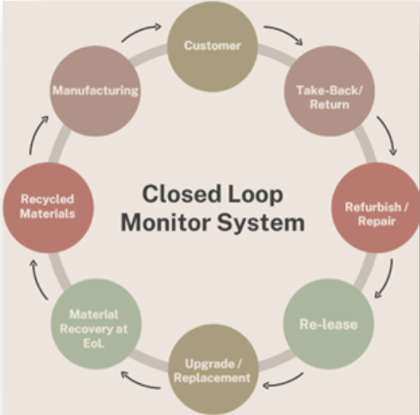
Closed-Loop System: At the end of each lease cycle, monitors are returned, inspected, repaired, upgraded, and reissued. Components that cannot be reused are recycled, ensuring continuous material recovery High-value materials like aluminium and copper are recovery Together, these strategies directly address every hotspot identified earlier.

Product design improving that we made in our new 24 inch OLED monitor
Materials
We replaced high-impact virgin materials with low-impact alternatives
- Recycled aluminium & steel (reduces embodies energy compared to virgin metals)
- Recycled glass,( Reduces extraction of silica and minerals and lowers emissions from glass production)
- Brass for making, (Brass is highly recyclable and easy to recover so it significantly reduce environmental impact in the early life cycle stages.)
- Bioplastics for the casing. (Bioplastic cuts fossil based plastic use and improves recyclability at end-of-life
- Recycled ABS for internal structures
(Using recycled materials because recycled materials reduces the use of newly acquired materials and reduces total embodied energy.)
Energy-efficient Design: our 24 inch OLED monitor uses less electricity, directly reducing the use-phase hotspot identified in the LCA.
Raw material sourcing for our monitor
To support our circular-economy business model, all raw materials for our eco-friendly monitor were sourced from certified low-impact suppliers in Ireland and the UK, suppliers located close to the manufacturing site were selected
Irish Suppliers
- Leinster Metal Recycling (Ireland) – Recycled aluminium
- Glass Recycling Ireland – Recycled glass cullet/sand
UK Suppliers
- Biome Bioplastics (UK) – Sustainable bioplastics
- MBA Polymers (UK) – Recycled ABS polymer compounds
- Green Applelec (UK) – Sustainable LED light sheets

Sustainable design strategies which we used for our 24 inch OLED office monitor
Reduced Packaging: We decided to Use smaller boxes to pack the device and using 100 recyclable cardboard will reduce production costs and will be easy to distribute.
Designed for Disassembly: Designing for disassembly ensures that all the parts can be removed and be reused and recycled. This lowers disassembly time, making recycling cheaper and more efficient.
Improved Energy: our 24 inch OLED office monitor can automatically adjust the brightness and has a LED backlight all of which contribute to the reduction of energy consumption. Moreover, increases its lifetime. Our 24 inch OLED monitor cuts use-phase emissions by more than 60%, which directly targets the largest hotspot identified.
Manufacturing location & transport
Our New 24 inch OLED office monitor is manufactured in Germany because Germany is highly regulation-driven in sustainable electronics manufacturing. The country enforces strong environmental and safety standards such as RoHS, WEEE, and REACH, ensuring sustainable production, transparency, and high labour/environmental standards. This aligns directly with our business model’s commitment to ethical sourcing, low-pollution production, and long-term circularity.
All raw materials from Ireland and the UK will be transported to Germany by ship.
- Because Shipping is the most sustainable and efficient method of international goods movement.
- Ships produce far less CO₂ per tonne-kilometre than trucks, and dramatically less than air freight and as I had mentioned above I wanted to reduce our co2e comparing to general monitor.
- Modern ships use improved engines, energy-efficient hull designs, and larger cargo capacity, which further reduce emissions.
Although shipping contributes to 3% of global CO₂, this is because it moves the majority of the world’s trade making it the greenest option per unit of cargo moved
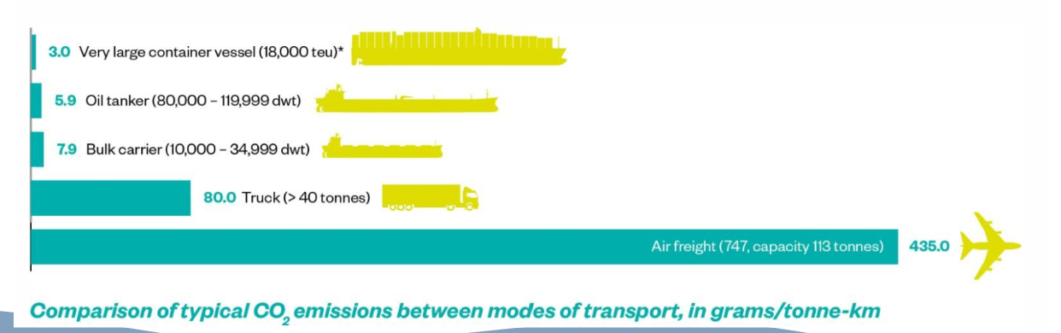
Key Changes we made to our monitor are:
- We removed virgin aluminium and steel. – Because they have high embodied energy and large greenhouse gas footprints.
- Remove plastic components and expanded polystyrene (EPS) packaging- both are non-biodegradable, removing them can improve recyclability.
- Remove adhesives and non-modular components removing them can make disassembly easier

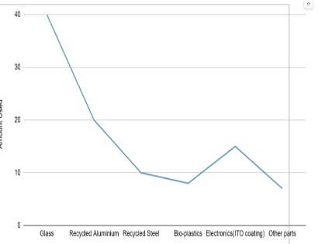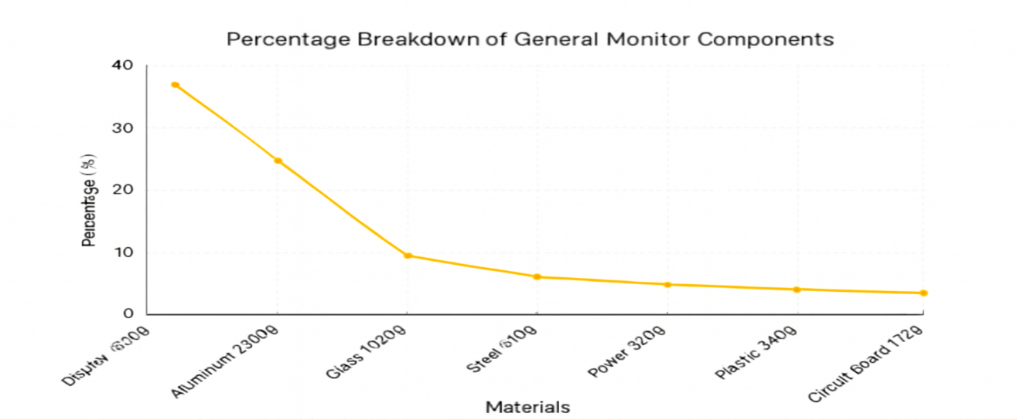
Our monitor materials
Vs
General monitor Materials
This graph compares our monitor's lifecycle energy use with general monitor. Our biggest improvement is in the use phase, where our monitor consumes less energy over its lifetime because that decreases the raw materials and manufacturing value rises slightly to balance the overall impact. But Even so, when you combine raw materials and manufacturing, which together represent production, our production impact is still lower than general monitor showing a more sustainable overall design.
LIFE CYCLE ASSESSMENT COMPARISON: OUR MONITOR vs. General MONITOR

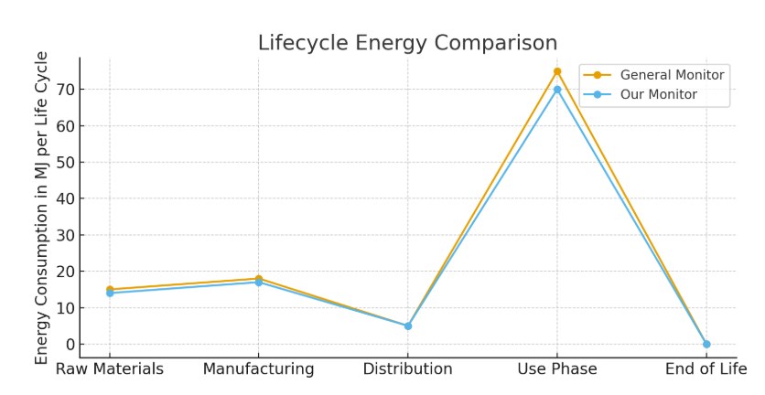
Life Cycle Assessment (improved product)
We conducted a detailed hotspot identification analysis. This allow us to focus our redesign efforts where they will make the most significant difference. First, we zeroed in on the most significant hotspot, the use phase. We calculated the annual energy consumption across three different screen technologies. As you can see, we broke it down by usage scenario, productivity, video streaming, and dark mode use. And full brightness tasks. The original CCFL LCD technology used in older monitors consumes 162 kilowatts of energy per hour per year. But the real game changer is the OLED technology, which slashes annual consumption all the way down to just 50 kilowatts per hour.

Annual Energy Consumption Calculation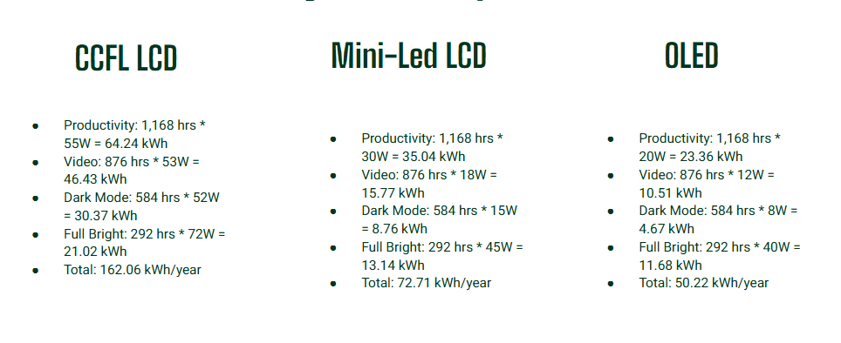

The calculation allowed us to identify the most energy-efficient technology for our 24 inch OLED office monitor.
Annual Energy Consumption Calculation chart
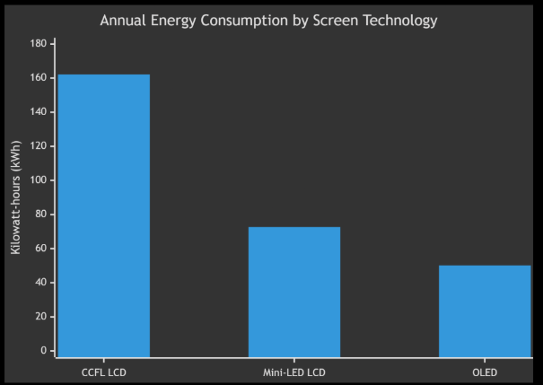

- CCFL LCD has the highest energy consumption, at around 160 kWh per year.
This shows that older backlighting technology is much less energy-efficient.
- Mini-LED LCD uses about half as much energy, roughly 80 kWh per year.
This demonstrates a major improvement due to more efficient LED backlighting.
- OLED has the lowest energy consumption, around 50 kWh per year.
OLED panels can turn off individual pixels, which reduces electricity use.
- Moving from CCFL to Mini-LED or OLED greatly reduces energy demand during the use phase.–
This analysis helped us show that transitioning to modern display technologies significantly reduces electricity consumption a major hotspot in monitor LCAs. Therefore, energy-efficient LED technology was selected for our new monitor.
Cumulative Energy Demand Calculations Over 5 Years
Lifecycle Stage | General Monitor | Our New 24 inch OLED office Monitor | Calculations
Manufacturing | ~450 MJ | ~150 MJ | Based on 90% recycled aluminium, bioplastics and recycled ABS reducing embodied energy by ~66%
Transportation | ~180 MJ | ~90 MJ | Localized EU sourcing vs global Apple supply chain reduces transport energy by ~50%
Use Phase | 2917 MJ | 904 MJ | CCFL (810 kW/h) vs OLED (251 kW/h)
End Of Life | 0MJ | -45 MJ | Energy credit from high-value material recovery
General monitor consumes 3547 mega joules of total energy over five years. The vast majority of this, over 80%, comes directly from electricity used during operation. Our new 24 inch OLED model in contrast, has a total CED of just 1099 mega joules. This represents a 60% reduction in total energy demand. To put it another way, our new 24 inch OLED monitor uses less than 1/3 of the energy of the general monito.
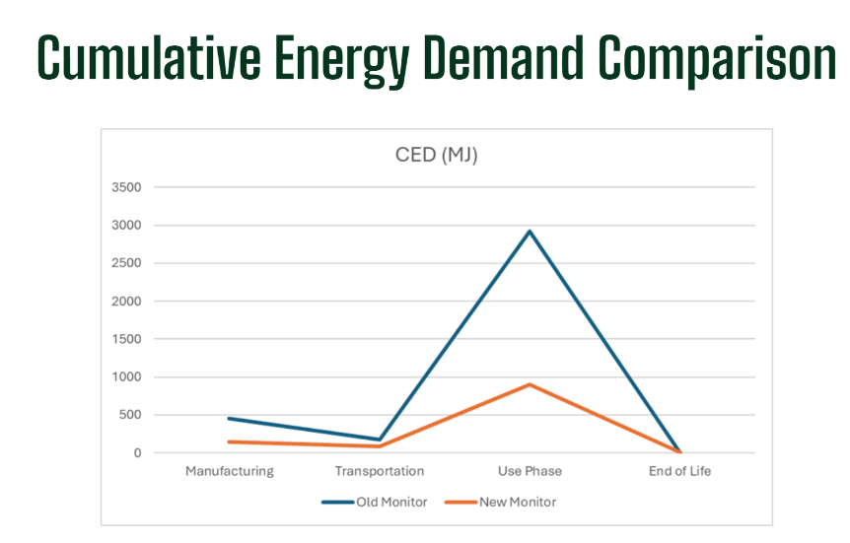
Conclusions:
In this project, we show that applying a circular economy approach in the electronics sector is an effective way to reduce environmental impacts and tackle the main hotspots identified in our Life Cycle Assessment. Since products like office monitors create major impacts during manufacturing, use, and disposal, we emphasize how strategies such as reuse, repair, refurbishment, and material recovery can extend product lifespans, save resources, and cut down on e-waste.
Our redesigned 24-inch OLED office monitor demonstrates how these ideas can be put into practice. We achieved improvements like lower energy use, modular components, a company-run take-back program, and refurbishment options, all of which reduce life cycle impacts compared to the baseline. By extending product life and keeping materials in a closed-loop system, we lower manufacturing impacts and prevent valuable resources from being lost to landfill.
Overall, we show that sustainable technology design is possible when environmental goals are built into both products and business models. A circular approach not only reduces resource use and emissions but also supports long-term sustainability in the electronics industry. By rethinking how devices are made, used, and recovered, we help move toward a more efficient and environmentally responsible future.

References:

- https://biomebioplastics.com/
- https://bageplastics.com/
- https://www.recycling.ie/
- https://www.applelecgroup.co.uk/
- https://leinsterrecycling.ie/
- https://www.mba-polymers.com/
- https://wwf.org
- https://greenly.earth
- https://www.google.com/search?q=Thunderbolt+Display+Environmental+Repor&oq=Thunderbolt+Display+Environmental+Repor&gs_lcrp=EgZjaHJvbWUyBggAEEUYOTIJCAEQIRgKGKABMgcIAhAhGI8CMgcIAxAhGI8C0gEHNjM3ajBqN6gCALACAA&sourceid=chrome&ie=UTF-8

